Our mission is to make an algorithm to reduce the traffic signal time to make it more efficient and automated.

Mostly in many cities like Bangladesh has traffic police here they use waki-Toki to make the signal on and off after confirming from another side of the road whether there is more number of cars are being jampacked. Moreover, in every traffic circle, suppose there are 4 roads where every road has two-lane of in and out. The number of traffic police needed is at least 4 to control the signal.

Further, where there is an automatic traffic control system they use fixed time signal or traffic load sensors to feed data into a cabinet which is nothing but a small computer. This sensor mainly detects weights of the road vehicle which is totally inefficient to detect numbers of vehicles.

Moreover, in many cities like China with the help of computation power and machine learning algorithms gov. are trying to introduce new algorithms to optimize the time of the traffic signal.

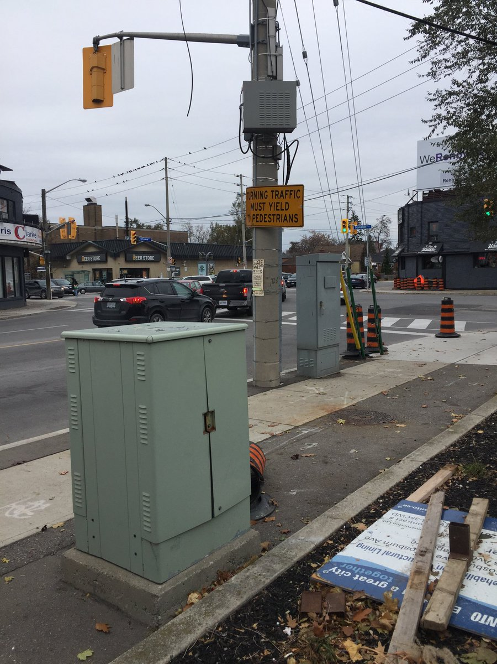

In our algorithm, we will consider all the parameters which are the main decider of controlling traffic signal. In typical traffic signal -

* Multiple cross signal co-ordination
* Space
* Cost
* Approach Speed
* Cycle
* Node distances
* Human factors
* Reaction time
* Standardization

Etc factors are considered. So let’s dive into the algorithms.

Our algorithm has three parts.

1. Different types of car detection with the help of CNN network
2. Train the predefined model with deep neural network
3. Calculation of optimizing time with avg speed and number of vehicles

***Different types of car detection with the help of CNN network***

We will imagine the total number of traffic nodes is five, wherein every node has 4 roads and in every road there are one way to in and other for the outgoing vehicles.

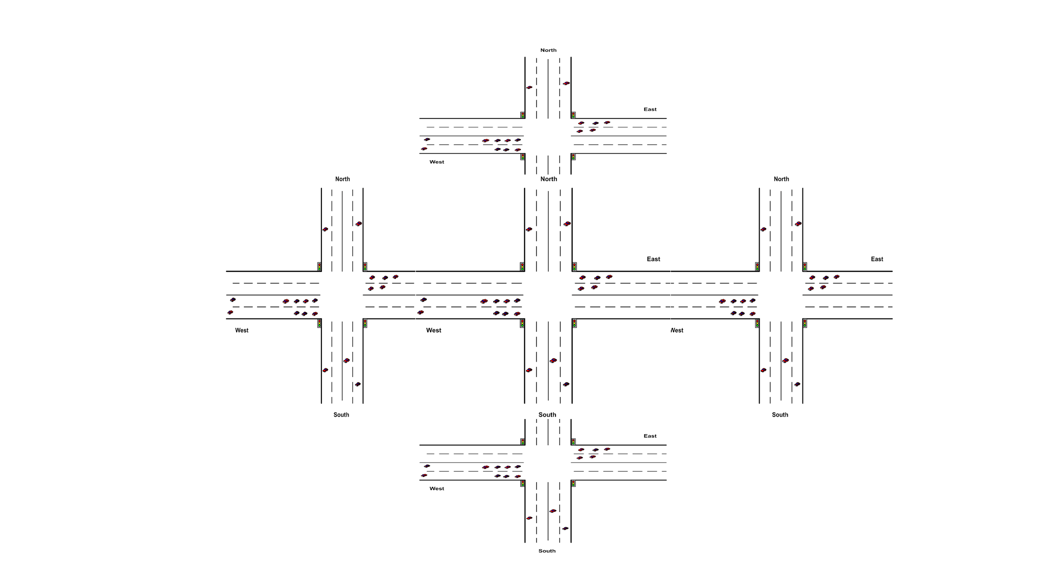

**Step-1:**

Let’s consider the central node. There will be four cameras in every outer lane of all four roads. We will capture images simultaneously from every camera. On an important note, we will capture images instead of video capturing to save power efficiency.

**Step-2:**

Next part we will count the number of cars, buses, and trucks.

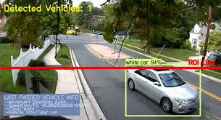

We will analyze different algorithms to see their efficiency if possible. We will apply our transfer learning to these model such as:

1. [YOLO: Real-Time Object Detection](https://pjreddie.com/darknet/yolo/)
2. [SSD: Single Shot MultiBox Detector](https://research.google.com/pubs/pub44872.html)
3. [Towards Real-Time Object Detection with Region Proposal Networks](https://arxiv.org/abs/1506.01497)
4. [A closer look at Faster R-CNN for vehicle detection](https://ieeexplore.ieee.org/document/7535375/)

***Train the predefined model with deep neural network***

* ***Input Data to Predict***

**Step1:**

**Arrange data ascendingly.**

We will arrange ascendingly the road name with the help of cars, bus, trucks number. But rather than taking only the number of the car, we will consider the lengths.

Suppose: Ideal Car length: 4.48 meter

Ideal Bus length: 9.14 meter

Ideal Truck length: 7.92 meter

Ex:

Suppose- A1 road- Car-10

Bus-2

Truck-1

Suppose- A2 road- Car-4

Bus-5

Truck-1

Suppose- A3 road- Car-20

Bus-1

Truck-1

Suppose- A4 road- Car-13

Bus-7

Truck-1

So Total length for A1: 70.98

The total length for A2: 71.54

The total length for A3: 106.66

The total length for A4: 130.14

This data we will preserve in the cache will be needed in our next step.

So we will assign integer value in python dictionary A1=4, A2=3, A3=2, A4=1

**Step2:**

***Redundancy problem handling:***

Suppose one of the roads is so busy that all the time number of vehicles is always higher than the other roads. So only implementing the ascendingly algorithm will give us bug. So we will consider the previous states of the roads in every 4 cycles for nodes.

Ex:

Suppose A1 has opened in the last signal cycle and A2 has opened two times in the last cycle. And we will make a threshold for a maximum opening of a road in 4 signals. So our next data will be:

prestateA1=1

prestateA1=2

prestateA1=0

prestateA1=0

**Step3:**

***Connecting to other nodes:***

In big cities, all the roads are connected with each other. If any node fails the other nodes will get affected. So we need the consideration of the other nodes states which we will get from our servers.

Ex:

Suppose the back node of A1 is open and others are closed.

BacknodeA1=1

BacknodeA2=0

BacknodeA3=0

BacknodeA4=0

* ***Training Model***

A sample dataset is shown for predicting signal which is to be open.

*Ex:*

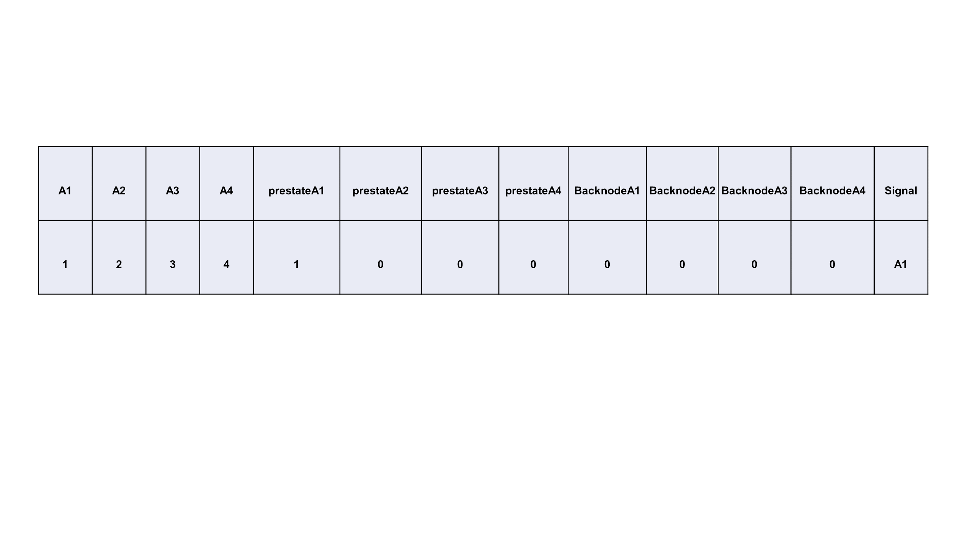

A1=1 (A1 road has most traffic)

A2=2 (A2 road has more traffic than A3)

A3=3 (A3 road has more traffic than A4)

A4=4 (A1 road has less traffic)

prestateA1=1 (A1 road has open one time in last 4 signal cycle)

prestateA1=0 (A2 road has open zero time in last 4 signal cycle)

prestateA1=0 (A3 road has open zero time in last 4 signal cycle)

prestateA1=0 (A4 road has open zero time in last 4 signal cycle)

BacknodeA1=0 (A1 back road is closed)

BacknodeA2=0 (A2 back road is closed)

BacknodeA3=0 (A3 back road is closed)

BacknodeA4=0 (A4 back road is closed)

This predetermined model is trained and tested by our deep neural network.

Our prediction result:

***Calculation of optimizing time with avg speed and number of vehicles***

Lets we have got our expected output from deep neural network model. Suppose , the answer is A1 road- Car-13

Bus-7

Truck-1

The total length for A1: 130.14 meter

And lets A1 has 3 lanes. So in every lane length (140.14/3)=43.38. Max limit in Dhaka city is

25 km/h or 6.94 m/s.

<https://www.rhinocarhire.com/Drive-Smart-Blog/Drive-Smart-Bangladesh.aspx>

Min acceleration : 0.28 m/s

Acceleration-Deceleration Behaviour of Various Vehicle Types-by P.S.Bokare a , A.K.Maurya b

So on time for every signal is :

t=sqrt(2*s/0.28)

=sqrt(2*43.38/0.28)

=309.85 s

= 5.16 min

**1. Scope of the project:**

Our target is developing a traffic management system to reduce time in traffic system with the help of CNN and Deep Neural Network in the context of a developing country. Our system will ensure or better mass-productivity and safety by lane management of busy traffic-prone roads in main cities.

**Ref:**

**1.** [**https://en.prothomalo.com/bangladesh/Dhaka-s-traffic-jam-causes-Tk-370b-annual-loss**](https://en.prothomalo.com/bangladesh/Dhaka-s-traffic-jam-causes-Tk-370b-annual-loss)

**2.** [**https://www.thedailystar.net/frontpage/colossal-loss-1553002**](https://www.thedailystar.net/frontpage/colossal-loss-1553002)